**Creating RestFul web service** :-

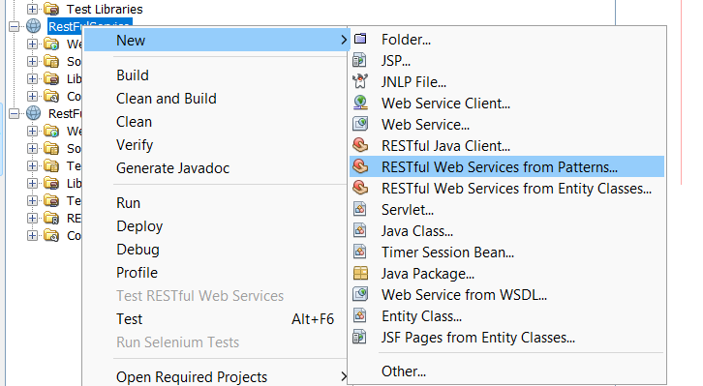

**Code** :-

package StringOperationPackage;

import javax.ws.rs.core.Context;

import javax.ws.rs.core.UriInfo;

import javax.ws.rs.Consumes;

import javax.ws.rs.Produces;

import javax.ws.rs.GET;

import javax.ws.rs.Path;

import javax.ws.rs.PUT;

import javax.ws.rs.core.MediaType;

/**

* REST Web Service

*

* @author Lenovo

*/

@Path("generic")

public class GenericResource {

@Context

private UriInfo context;

public GenericResource() {

}

@GET

@Produces(MediaType.TEXT_HTML)

public String getHtml() {

//TODO return proper representation object

throw new UnsupportedOperationException();

}

/**

* PUT method for updating or creating an instance of GenericResource

* @param content representation for the resource

*/

@PUT

@Consumes(MediaType.TEXT_HTML)

public void putHtml(String content) {

}

@PUT

@Consumes(MediaType.TEXT_HTML)

@Path("/Uppercase")

public String toUpperCaseMethod(String str)

{

return str.toUpperCase();

}

@PUT

@Consumes(MediaType.TEXT_HTML)

@Path("/Lowercase")

public String toLowerCaseMethod(String str)

{

return str.toLowerCase();

}

}

Clean, build and deploy project :-

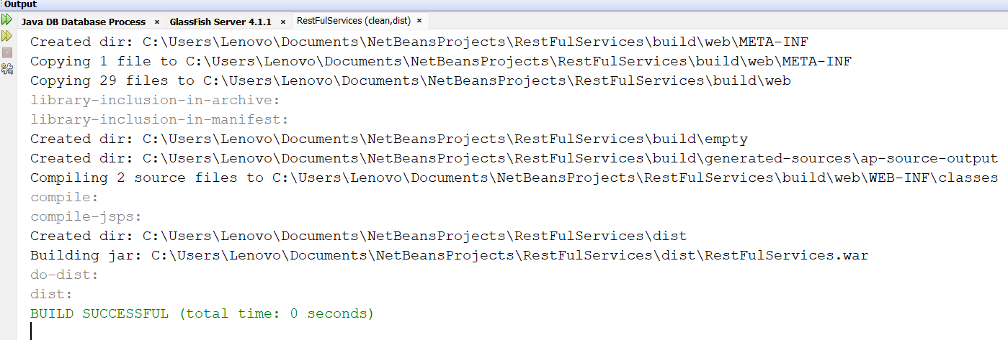

Testing the web service :-

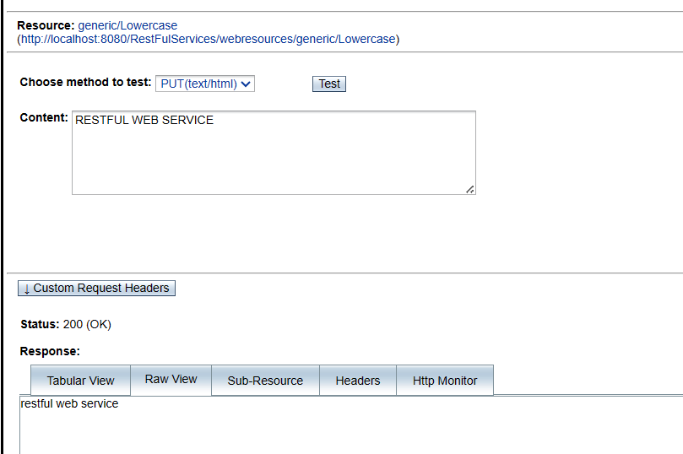

**Consuming RestFul Web Service** :-

Select RestFul Java client

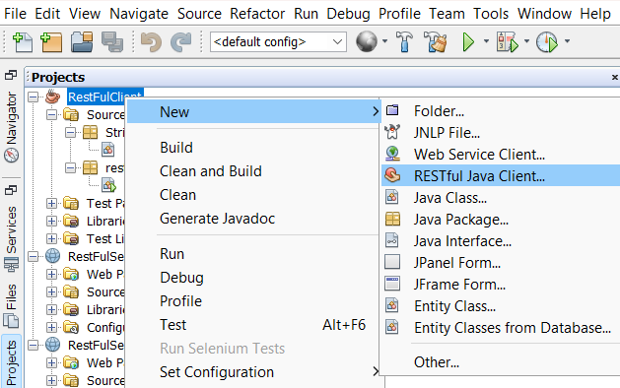

**Code for RESTFul Client** :-

package restfulclient;

import StringPackage.StringOpertaionClient;

import java.util.Scanner; // Importing Scanner class

/**

*

* @author Lenovo

*/

public class RestFulClient {

/**

* @param args the command line arguments

*/

public static void main(String[] args) {

StringOpertaionClient client = new StringOpertaionClient();

// Create a Scanner object to read input from the user

Scanner scanner = new Scanner(System.in);

// Prompt the user to enter a string

System.out.print("Enter a string: ");

// Read the input provided by the user

String inputString = scanner.nextLine();

// Call the toUpperCaseMethod() and toLowerCaseMethod() methods and print the results

String upperCaseResult = client.toUpperCaseMethod(inputString);

String lowerCaseResult = client.toLowerCaseMethod(inputString);

System.out.println("Uppercase: " + upperCaseResult);

System.out.println("Lowercase: " + lowerCaseResult);

// Close the scanner to release system resources

scanner.close();

}

}

**Output** :-

